**Online Education Employment (Android) Project**

**Project Management Plan**

Version: 1.0

Date: 12 Aug. 2015

Document Modification History/Revision log

|  |  |  |  |
| --- | --- | --- | --- |
| Version | Date | Author | Description of Change |
| 1.0 | 12/08/2015 | VEL team | Initial version |
|  |  |  |  |
|  |  |  |  |
|  |  |  |  |
|  |  |  |  |

Contents

1. Introduction 3

1.1. Project Overview 3

1.2. Project Approach 3

1.3. Project Practices 4

1.4. Project Artefacts 4

2. Requirement 5

2.1. Product Backlog 5

2.2. Sprint Backlog 5

3. Project Timetable and Schedule Monitoring 7

3.1. Client Meeting Plan 7

3.2. Team Meeting Plan 7

3.3. Project Development Plan 8

3.4. Risk Management Plan 10

3.5. Change Management Plan 10

4. Project Configuration 11

4.1. Plan Management Tool 11

4.2. Source Management Tool 12

# Introduction

This Project Management Plan applies to the project “Online Education Employment (Android) Project”. The Project Management Plan is required reading of all team members of this project. The current version of the Project Management Plan is located at GitHub “761_VEL”. The plan is a living document that is updated when changes are made to the scope of the project.

## Project Overview

**Overall Project Goal:**

The goal of this project is to create an adaptive (mobile friendly) website to help IT students and unemployed people to get useful skills. The home page should show some successful stories and draw visitors’ attention so that they would like to register as fixed users.

**Major Capabilities:**

1. The visitor can view the website and scan the course list. They can also take a test without registering.
2. The system (course advisor) can give the user a short survey and then give a list of successful examples about those who found a job after taking courses on the website and recommend some suitable courses according to the survey.
3. The user can select courses and make payments online. After that they can take courses via video or audio.

## Project Approach

The project will use a customized agile development model. It includes releasing planning phase, design phase and 3 prints. . The tasks in every sprint include designing, coding, testing, sprint review and retrospective.

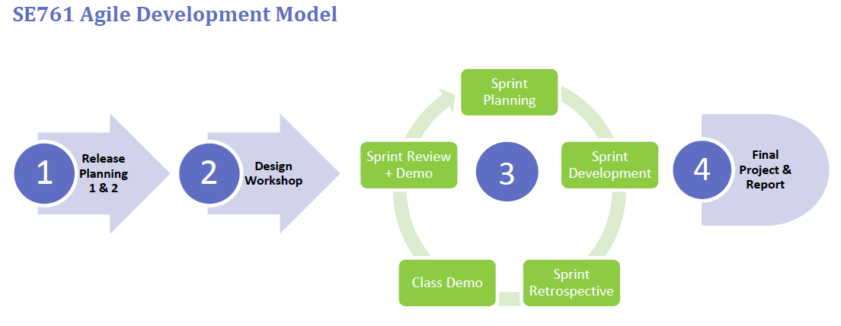

## Project Practices

The following core practices will be applied to this project.

1. Release Planning
2. Sprint Planning
3. Daily Scrum
4. Self-assignment
5. Cross-functionality
6. Work-in-Progress Limits
7. Rotating Scrum Master
8. Pair Programming
9. Architectural Spikes
10. Sprint Review (including Demo)
11. Retrospective

## Project Artefacts

The project will use these following agile artefacts.

1. Product Backlog
2. Sprint Backlog
3. User Stories
4. Tasks
5. Release Plan
6. Design Documents
7. Scrum Board
8. Burn-down charts

# Requirement



## Product Backlog

## Sprint Backlog

This is the Sprint Backlog for the first Sprint, which will start from 17 August to 30 August, 2015. According to the product backlog which is prioritized by customers, they value more about the self- adaptability and basic functions of the website. Considering there is no conflict between these two aspects, in the coming sprint, the team will focus on the user stories list here.

|  |  |  |  |  |  |  |  |  |
| --- | --- | --- | --- | --- | --- | --- | --- | --- |
| **User story #** | **Theme** | **Task #** | **Task** | **Description** | **Estimate** | **Start** | **End** | **Comment** |
| 1 | Self-adaptability | 1.1 | CSS learning | Training team CSS for adjusting layout and content dynamically | 1 |  |  |  |
| 1.2 | Dpi detection | Detecting and obtain the dpi of user's screen | 0.5 |  |  |  |
| 1.3 | Content modification | Dynamically adjust the content of website such as display status and layout based on dpi | 1.5 |  |  |  |
| 2 | Self-adaptability | 2.1 | Device detection | Acquiring the device type(mobile, pad and pc) | 0.5 |  |  |  |
| 2.2 | Framework modification | Choosing different frameworks to display the content based on the device type | 1 |  |  |  |
| 3 | Registration | 3.1 | Authenticate user | Achieving the function  of login and logout | 1.5 |  |  |  |
| 4 | Courses | 4.1 | Course list | Displaying all available courses | 0.5 |  |  |  |
| 4.2 | Course bill | Putting the courses which are selected by user into shopping basket | 1 |  |  |  |
| 5 | Success stories | 5.1 | Success stories board | Demonstrating all success stories on a board | 1.5 |  |  |  |
| 5.2 | Helpful courses | Showing the successful user's courses in every success stories | 0.5 |  |  |  |

# Project Timetable and Schedule Monitoring



## Client Meeting Plan

## Team Meeting Plan

Team internal communication plan defined as below:

|  |  |  |  |  |  |
| --- | --- | --- | --- | --- | --- |
| No. | Meeting | Purpose | Participant | Frequency | Time |
| 1 | Daily Scrum | Check team progress regularly | All team members | Weekly | As following |
| 2 | Sprint Planning | Confirm user stories, break it down into tasks and discuss the design of it | All team members,  Product owner | Bi-weekly | Friday,  9:00 ~ |
| 3 | Retrospective | Discuss what is good or bad in last sprint and make new strategy to improve the process | All team members,  Product owner | Bi-weekly | Friday  11:00 ~ |
| 4 | Design meeting | Discuss the architecture and design of function to make sure team members understand the details | All team members | <TBD>  Base on the result of daily scrum | <TBD> |

Timetable of regularly weekly meeting

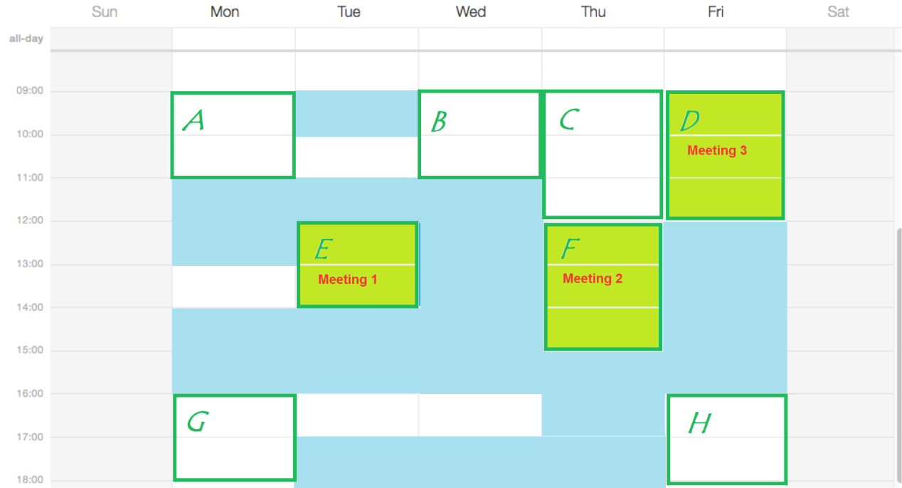

## Project Development Plan

Software development approach is consist of 4 parts: Design Workshop and Sprint 1,2,3. In the design workshop, a mock up model will be delivered, as a demonstration of what can be done, and how system works. And in each following sprint, core functionality will be built, and new features will be incrementally add. Software Testing will be applied within each sprint to ensure functionality correctness, usability and robustness of the system.

**Design Workshop (Duration 1 week)**

A mock up system with minimum functionality and show case of adaption to different size of device will be developed. Including web site main page, course list and course details.

Each page should be fully customized to adapt desktop/laptop, tablet and mobile phone. Program should be able to detect and apply customized layout framework for each screen size.

Deliverable consist of a demo system with mock up data.

**Sprint 1**

Core function of the system will be developed in this phase, including main page, course list and course detail, dynamic menu, course category. Each page will be applied by size adaption framework, tuned and tested on each screen size device. Server interaction will be concurrently developed.

Deliverable consist of minimum fully functional online course web site, with well tuned adaption to each screen size device from desktop/laptop, tablet to mobile phone.

**Sprint 2**

Implement visitor customized content, categorized success stories and dynamic recommended courses. Focus on functionality on recognition of visitor’s personal background and behaviour, generate customized content for each type of visitor, display successfully stories and corresponding courses which leads to high possibility of commit deals.

Deliverable consist of visitor recognition functionality, dynamic content based on visitor’s category, successful stories and list of corresponding courses. Integrated with sprint 1.

**Sprint 3**

On-line help desk, shopping cart, and other potential customer requirements. These are add-on features to the system. According to the customer, these functionalities need further discussion. As for now, development plan for this part of the project is not clarified. Refinement of product backlog will be done along while project on-going.

Deliverable to be decided.

**Software Testing**

Test scenarios will be designed and test cases will be executed within each sprint. Defect management tool will be used on demands. Defects will be labelled with 3 levels of severity:

• Critical – system clash, module level failure, infrastructure failure, etc.

• Major – functional misbehaviour, missing functionality, etc.

• Minor – layout issue, user friendly issue, issues with work around, etc.

Testing scope include unit testing, integration testing and system testing. There will be organized integration testing and system testing within each sprint, before customer acceptance tests.

Deliverable consist of test reports.

**Software Release**

System will be bundled as deployable, together with design documents, test reports, installation guide and user guide.

## Risk Management Plan

Risk Management is a process that ensures any issues are identified early and addressed before they jeopardize project objectives. The process will follow all stages from creating a risk management strategy through managing risk tracking to executing a risk management plan.

The Risk Tracking will be carried out after daily scrum. It is used to manage Risks that have a significant effect on project progress and outcomes. In addition to managing Risks, the process provides a method for documenting the rationale behind risk mitigation decisions made during one stage of the project that may affect a later stage.

Supporting this process is the Risk Tracking table that provides a centralized location for tracking Risks. Documentation for this can be found in the GitHub, located /PCB/02 Plans & Actuals/2.3_Risk & Issue. The Risk Tracking Process and tool allow the user to identify and assess each risk, as well as track the progress towards mitigation.

## Change Management Plan

# Project Configuration



## Plan Management Tool

**SeeNowDo** will be used to monitor project approach, user stories, sprint plans, and development progress. Meanwhile, burn-down chart is provided to indicate whether the project is meeting its target schedule and budget.

* URL to login SeeNowDo:

<https://www.seenowdo.com/pages/login/index.xhtml>

* Project Name: **OEE(Android)**
* Image of project & iterations (sprints)

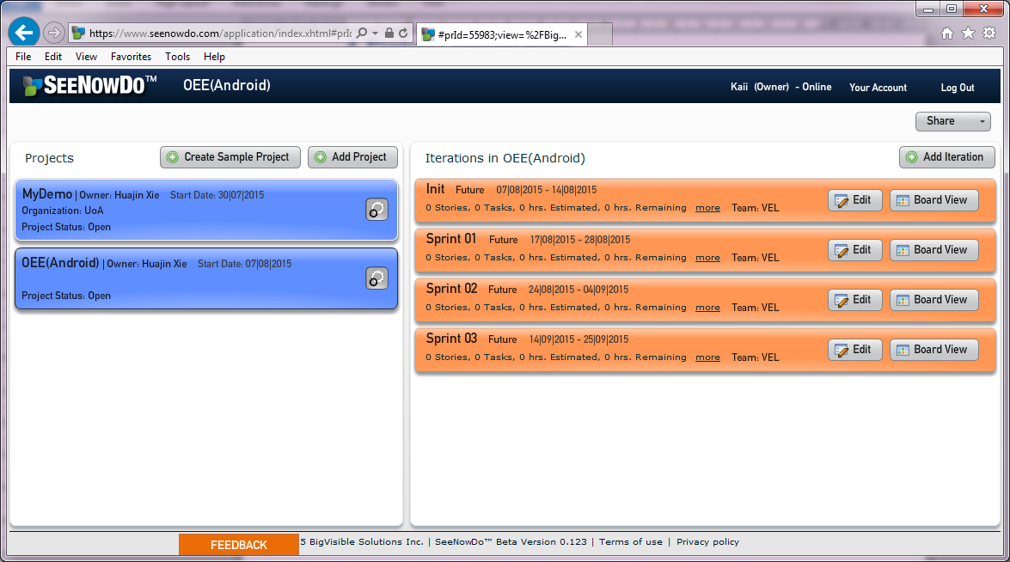

* Image of user stories & Sprint Plan

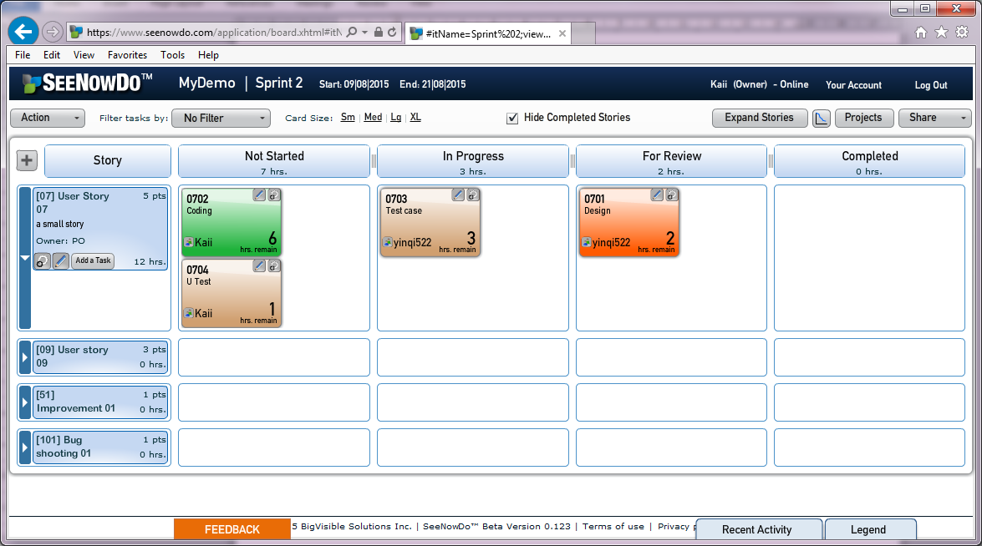

* Burn-down Chart

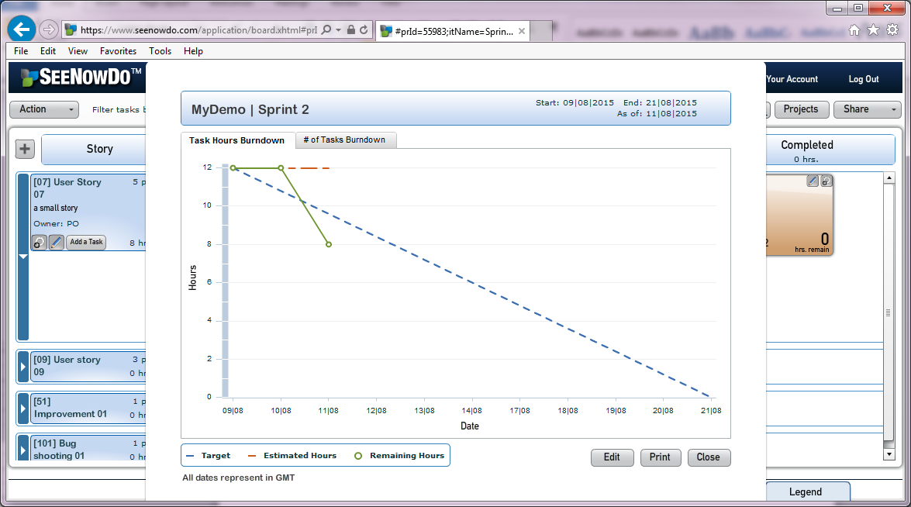

## Source Management Tool

GitHub will be used to manager documents and source file.

* URL to login GitHub:

<https://github.com/>

* Project Name: **761_VEL**
* Image of GitHub

